# HTML 5 Assignment

1. What are the new tags added in HTML5?

**Ans:-**

The commonly used new HTML5 tags are <figure>,<article>,<main>,<header>,<footer>,<nav>and<section>

Example:-

<embed> : - it define a containe for external file.

<source> :- it define multiple media resources for the media element

2)How to embed a video and audio in a webpage?

**Ans:-**

Create a new HTML file in same directory, called index.html.Add<audio> and <video> element to the page ; make them display the default browser controls.

Example:-

<embed type="video/webm" src="movie.mp4" width="400" height="300">



**EmbedAudio:-**

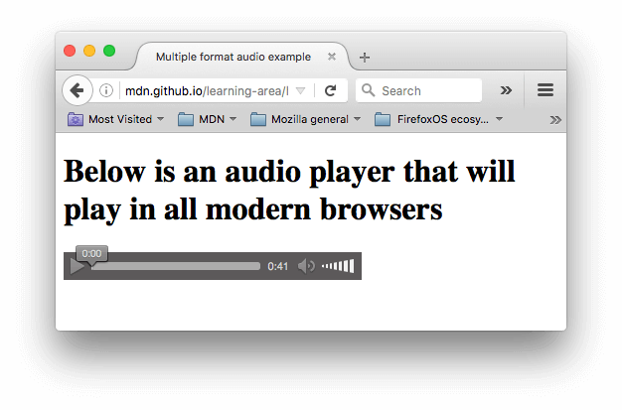

1. Semantic element in HTML5?

**Ans: -**

article>,<aside>,<details>,<figcaption>,<figure>,<footer>, <header>,<main,<mark>,<nav>,<section>,<summary>,<time>

1. Canvas and SVG tags

**Ans: -**

SVG is a language for describing 2D graphics in XML,while Canvas draws 2D graphics, on the fly (with JavaScript)

Example:-

<svg width="100" height="100">

<circle cx="50" cy="50" r="40"

stroke="green" stroke-width="4" fill="yellow" />

Sorry, your browser does not support inline SVG.

</svg>